1) The framework of contributory factors influencing clinical practice
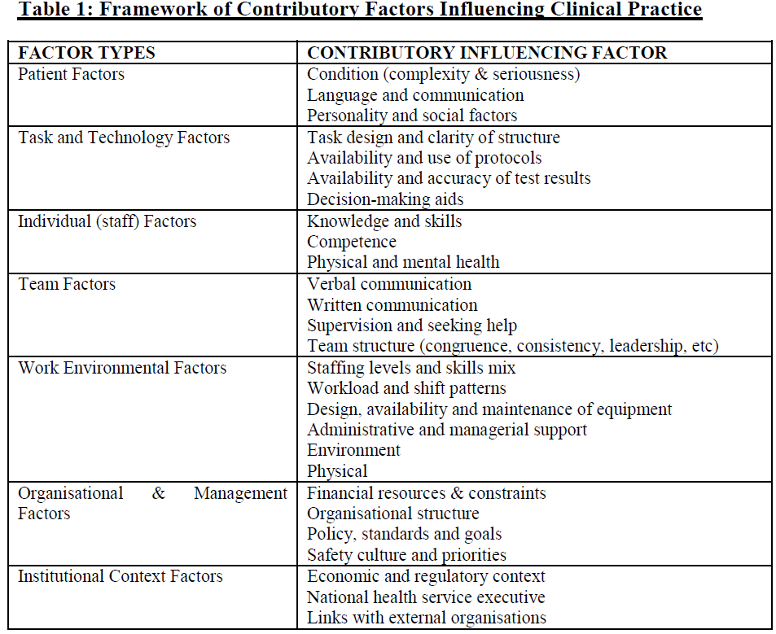

2) The key driver diagram for reduction in SSEs from Muething SE, Goudie A, Schoettker PJ et al. Quality improvement initiative to reduce serious safety events and improve patient safety culture. Pediatrics. 2012 Aug;130(2):e423-31.
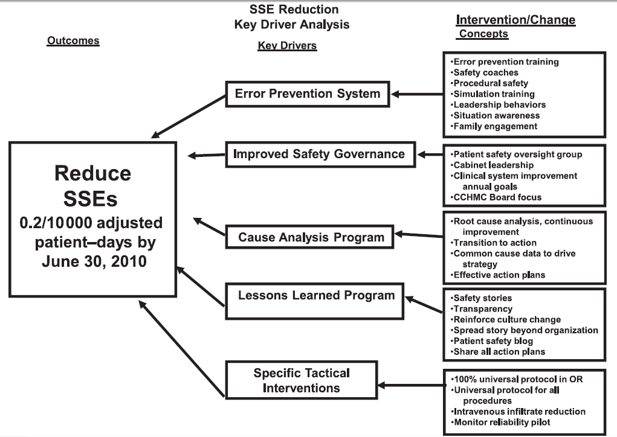

3) The control chart for the number of SSEs per 10 000 adjusted patient days from Muething SE, Goudie A, Schoettker PJ et al. Quality improvement initiative to reduce serious safety events and improve patient safety culture. Pediatrics. 2012 Aug;130(2):e423-31.
